Linear Grounding against Total Harmonic Distortion (THD) based on Faden spectrum phenomenon

Professor. Dr. Hazar Shtat* ORCID ID: 0009-0003-3953-8166
Professor. Dr. Nazih Haidar**

Abstract

This applied research deals with the effect of capacitive harmonics on the efficiency of electrical and electronic devices used in installing a giant screen owned by Faden Spectrum Company, which was installed on one of the huge towers in the city of Al-Khobar in the Kingdom of Saudi Arabia, with an area of 2000 square meters, and consisting of 2000 cabinets containing 2000 electrical cells.
The area of each cell is 1 m².

The problem was solved - significantly - by linear grounding, which also provided creative solutions for four similar screens of relatively smaller size, which may allow this type of grounding to be generalized to all electrical networks with similar problems.

Under our supervision, the engineering team worked to reduce the annoying noise coming from the main feed box (MDB), which was increasing steadily with increasing lighting intensity, to become 90 dB at 60% brightness and 155 dB at 100% brightness, by building independent linear grounding.

It deals with the zero-point grounding of the transformer, and this applies to the screen feeding system as a whole, provided that the old grounding remains as a grounding against touch currents to protect individuals from electrification.

Our engineers successfully reduced harmonic noise from 95 dB to 55 dB at 50% brightness (the normal operating rate for this type of display at noon).

The apparent current on neutral has also been reduced to 438A instead of 811A at the same brightness rating.

This solution also reduces the size of the active harmonic filter to less than half, saving a lot of money when the customer wants to reach typical values with a THD filter.

Keywords: Total Harmonic Distortion - modulation transformers - sine wave - electrocution - capacitive harmonics – THDi – THDv – APF/AHF – Linear Grounding.

-----------------------------------------------------------------
* Member of the Institute of Electrical and Electronics Engineers (IEEE) / Membership No. (95692956)
**Head of the Physics Department at the Faculty of Science, Tishreen University.
Introduction:
Harmonics are defined as frequencies that are multiples of the original frequency. If the original frequency is 50 Hz, then the harmonics will have frequencies equal to 100 Hz, 150 Hz, 200 Hz and are called 2nd Harmonic, 3dHarmonic, and so on... as the figure (1) shows.
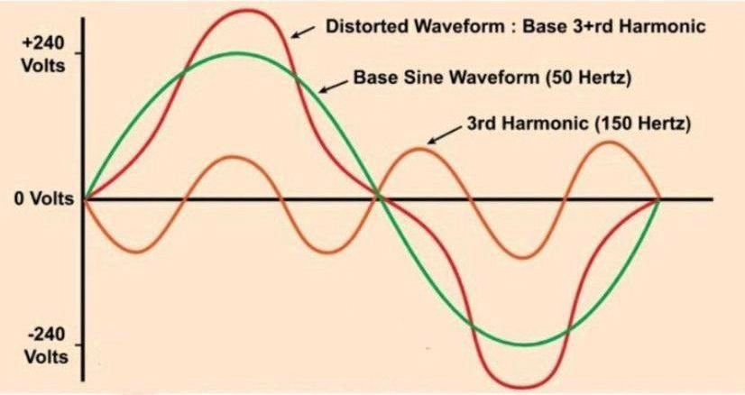
Figure (1): A basic sine waveform with a distorted waveform due to the third harmonic
These frequencies arise as a result of the presence of non-linear loads, through which non-sinusoidal currents pass. If these non-sinusoidal currents are analyzed according to the rules of the Fourier series, they consist of the original frequency loaded with different frequencies, which we call harmonics. [1]
One of the most important reasons for the emergence of harmonics is the presence of power sources connected to electronics devices such as transformers and Rectifiers Inverters for the purpose of obtaining greater control over the conversion of voltage between alternating and direct current, but the voltages emerging from these devices are often in the form of pulses, and these pulses distort the shape of the wave curve of the original sinusoidal wave, and from here the harmonics appear.
Total harmonic distortion (THD) can be a difficult concept due to the complexity of the power system and its many individual components.
THD is best understood when a power system is defined by its simplest parts – the power supply and the load, as shown in Figure 2[1].
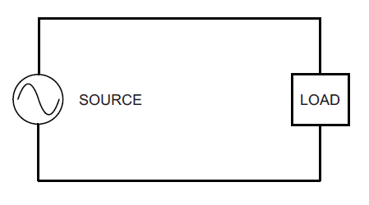
Figure (2). Most basic parts of the power system
Since load affects the current draw on a system, the system's power quality is often affected as well, depending on the type of load.
Loads can be linear or non-linear.
A linear load draws a sinusoidal current in nature and has smooth current and voltage transitions, so this generally does not distort the waveform as shown in Figure (3)[1].
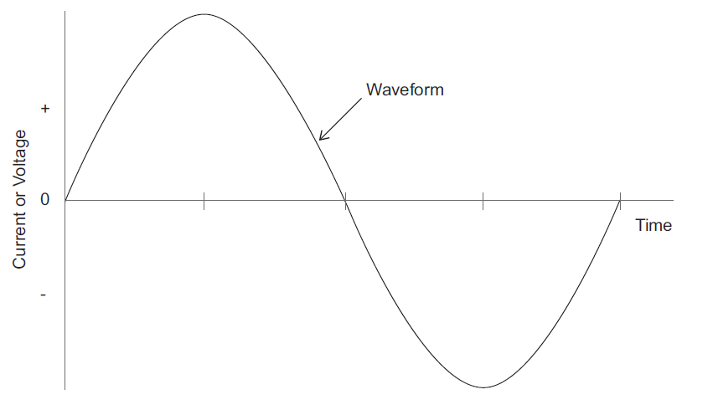
Figure (3). An ideal sine wave with a linear load supplied to the source
Many household appliances such as electric water heaters, baseboard heaters, irons, and incandescent lighting mostly have resistive loads, which are relatively linear.
Harmonic distortion is not usually caused by the power generation or distribution system itself and was not a real problem before 1960.
Now changes in technology are beginning to contribute to changes in load after nonlinear components such as diodes and SCRs (or thyristors) have begun to be integrated into electrical appliances and home appliances.
Higher energy efficiency lighting and government phase-outs of incandescent lamps are prompting consumers to replace older incandescent lamps with compact fluorescent lamps (CFL), light-emitting diode (LED) and electron stimulated scintillation (ESL) type lighting.
This type of lighting, although very energy efficient, does not provide a linear load like incandescent lamps.
Another new source of harmonic distortion comes from the variable motor speed controls that are now offered in many high-efficiency heat pumps.
These nonlinear devices introduce a nonlinear load on the power supply causing significant distortions in the source waveform as shown in Figure 4[1].
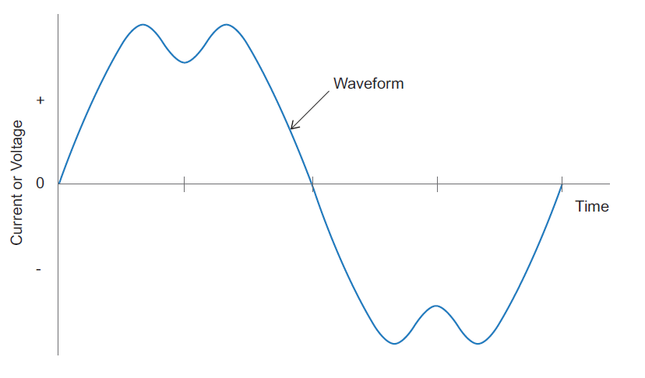
Figure (4). Wave distortion caused by nonlinear loads
Nonlinear loads cause waveform distortion, radically changing the waveform of the power supply.
It is important to note that a sine wave consists of even and odd harmonics.
Nonlinear loads usually cause odd-order harmonics to be more pronounced and problematic in a power distribution system.
This is because most electrical loads, with the exception of half-wave rectifiers, produce symmetrical current waveforms.
This means that the positive half of the waveform is a mirror image of the negative half.
This results in the presence of only individual harmonic values.
A half-wave rectifier can produce even harmonics as well as odd harmonics.
The illustration shown in Figure (5) shows the relationship between fundamental harmonics and odd harmonics resulting from nonlinear loads.
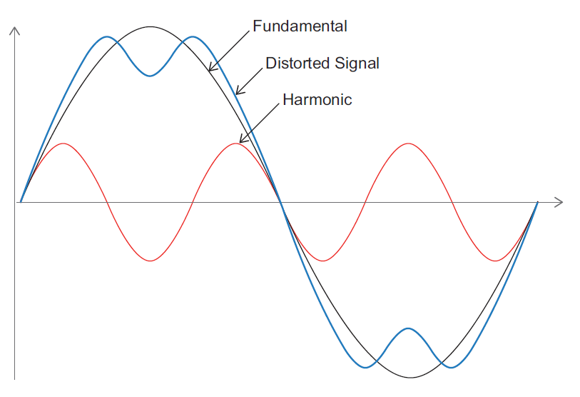
Figure (5). Relationship between fundamental and odd harmonics
Another factor that can sometimes cause an increase in harmonic problems is the capacitor banks that are used to correct the power factor of inductive loads.
If the capacitor resonance is at a multiple of the fundamental frequency, it can actually amplify harmonic problems.
Accurate design is important when installing capacitor banks and it is also important to monitor the THD and power factor as the inductive load may change from time to time as a result of new loads introduced by customers.
Effect of Harmonics:
The Harmonics reduce the efficiency of electrical devices and distort their good performance.
It also raises the temperature of power cables, capacitors, and electronic equipment, distorts measurement circuits and control circuits, and affects the performance of motors, generators, and electrical transformers [2].

In order to mitigate the sources of generation of strong harmonics in the network supplying the consumer, they must be treated locally by working to prevent the spread of their influence in the network.
But when it becomes difficult to reduce certain harmonics, the components of the network must be strengthened to the extent that they can withstand these harmonics.
This is done by doing the following:
-1 Increasing the cross-sectional area of the cables or adding new cables to increase the network’s ability to withstand high harmonics.
2 Reducing the capacity when loading transformers (from 50% to 70%) while adding new transformers or replacing existing transformers with high-capacity ones.
3-Redistributing the loads in three-phase networks to balance the harmonics as well as the load currents in all conductors. There are also procedures that can be taken to reduce the size of the harmonics problem or eliminate it completely, such as:
- Adding inductive coils and reactors in series with capacitors. This method is the most common method.
- Adding inductive coils in parallel with the capacitors, and their reactance can be controlled to reduce the value of the harmonics.
- Using a filter consisting of capacitors and series and parallel coils (AHF) [2]
Problematic of Grounding Systems:
Until this moment, internationally approved grounding systems have not paid attention to exploiting good grounding to combat harmonics, especially capacitive loads, as the main concern of grounding systems up to now is protecting individuals and equipment from short circuits.
Interest in grounding was (in order to) and against Touch currents at the outputs of low-voltage transformer stations, and against step voltage. In transfer stations for medium lines and above, this is all we have, to start working.
also, we have Grounding against static electricity is a good job, but it does not help much in dealing with the problem of harmonics,
And that's all we have, to start with the Faden Spectrum screen problems that located on a giant tower in the city of Al-Khobar in the Kingdom of Saudi Arabia [3].
It is a giant screen with an area of 2000 square meters, where the readings were different from all scientific alphabets as well.
The results were shocking, in addition to the poor performance of the direct feed network to the screen, despite the fact that the transformers, feeder boards, and cable isolator's and lugs were built in accordance with the most precise regulations approved by the IEC, especially the IEC: 60502 specification and its amendments [4].
Electrical Grounding Systems:
Electrical grounding systems occupy a very wide field, including grounding of electric current generators, as well as grounding of electrical transformers.
Grounding the electronics is to ensure that they are not subject to interference.
Despite the breadth of this field, the literature usually presents it by explaining the methods of grounding various transformers and connecting the grounding point to the loads.
The focus is on grounding systems starting from the secondary end of the distribution transformer because before this point, from the primary end of the transformer all the way to the electrical generators, they are electrically isolated (but magnetically connected) from the secondary end of the distribution transformer, which makes it possible to ignore them for the sake of simplifying the topic.
Also, the secondary end of low-voltage distribution transformers is what ultimately feeds the loads, which makes the relationship between grounding the loads and these transformers a close relationship.
The field of electrical grounding systems is usually introduced by the IEC 60364 and IEEE 80/13 standards and the resulting literature in this field [5,6].
Therefore, this research will start from the same base and give a brief introduction to this field through these two standards. The goal of having electrical grounding systems can be summarized in two basic points:
A- Ground protection:
Connecting current-conducting surfaces, socket grounding points, etc., to the ground protects against exposure to electric shock by ensuring that the voltage of the current-conducting surfaces remains equal to the ground voltage. When the electrical insulation of any of the wires fails and it comes into contact with any metal surface, the current will pass directly to the ground instead of passing through the body of any person in contact with that surface, or passing through any flammable material and causing a fire, or passing through devices not designated for such a high current will causes damage. [5]
B- Functional Grounding:
What is meant by functional grounding is the grounding line that carries the current returning to the power source, as is done in some well-known grounding systems, and one of the power transmission systems that relies on the return of current through the ground is the Single-Wire Earthing Return system [7].
Grounding of L/V Electrical Grids:
After presenting the methods for connecting loads and various parts to the grounding points in the facility, you must know the relationship between those grounding points and the electrical distribution transformer, which will be explained in this part of the research.
There are different types of grounding systems and the choice of which system determines the type or protection requirements needed for the electrical system and how it is connected to loads.
These different types fall under three main types that are different from each other, and the network designer chooses any of them while designing the electrical distribution system according to his needs and in accordance with the standards and requirements followed in his country. The choice of the type of grounding system by the network designer will result in three important and independent decisions [8]:
• The method of connecting the neutral line in the network and its relationship to the visible parts and pieces of the loads.
• Use a separate Protective Earthing (PE) line/cable or combine it with the neutral line and use only one cable.
• How to use ground fault protection devices (from a short circuit to the ground or current leakage to the ground) to disconnect the circuit or give a warning of the presence of a ground fault.
The various grounding systems are also known as “Earthling System Arrangement” and they describe the method of grounding the lower part of the network on the secondary end of the MV/LV Transformers, specifically the neutral connection of the transformer,
and how to ground the visible parts of the electrical connections connected to the network.
Grounding methods also describe whether the transformer's neutral (N) and protective conductor (PE) are separate or connected together.
Finally, choosing whether using an overcurrent protection device is sufficient or whether there is a need for special protection to read and disconnect the circuit when the insulation of the conductors fails and there is a leakage current to the ground.
All these points are combined together and covered by the international standard IEC/IEEE as explained throughout this article [7,8].
The importance of the research and its objectives:
The importance of the research lies in arriving at an independent, safe and effective grounding system to mitigate the effect of harmonics on capacitive loads in existing mega projects, without being exposed to the old grounding and keeping it as grounding against contact currents to protect individuals from electrification.
The goal of the new linear grounding is to reduce the apparent amperage on the neutral line at the same illumination rate of screen and reduce the electricity bill as much as possible by reducing the waste resulting from VAr by diverting the return currents to the ground instead of returning them to the transformer by grounding the zero point of the transformer by connecting according to a system of TN-C at the investor's first MDB.
Research methods and materials:
1- Collecting field data:
The necessary data to begin work was obtained during the period between the last quarter of 2020 and the third quarter of 2021 through:
- Resorting to a professional company to obtain a serious report on the soil voltage and its specific resistance (attached is a copy of the report, named: Soil Resistivity Testing) [A]
- Resorting to a professional company to obtain a complete analysis of the electrical network that supplies the screen, including the total capacitive and inductive harmonics (attached is a copy of the report, named: Faden Screen - Power Analyze) [B]
- Continuous thermal imaging of the network throughout the work period using a Fluke TiS55 thermal camera with excellent memory and high resolution (attached are some of these pictures, PDF named: Adeer Thermal Photos) [C]
- Weekly data and reports that were provided immediately to the owners (some of these reports are attached under the title name: Status Reports) [D].
With the following standard specifications and their appendices were fully adhered to:
IEEE-80/2013 IEEE-519-2014
IEEE Std. 998 -2012
And, with the following specifications and their appendices, as partly:
IEC 60364-5-54
IEC 60502-1-2021
2- Description of the problem:
The screen in working mode was suffering from annoying and unacceptable harmonics on capacitive loads, even when it was operating at 50% of its actual capacity, while the temperature (which sometimes reached 83 - 90 degrees Celsius) was from the exit points of cables from the ceiling of the panel.
The main one is not well understood (Faden spectrum phenomenon).
The temperature of the cables was normal and close to the temperature of the ambient.
Only when the cables exited from the ceiling of the panel did their temperature rise to 83-95 degrees Celsius and then returned to their normal thermal nature once they moved away one mm from the ceiling of the panel.
This type of thermal entropy was difficult to understand at first glance and contradicted all the laws of thermodynamics in the universe.
Please see the thermal image below in Figure (6).
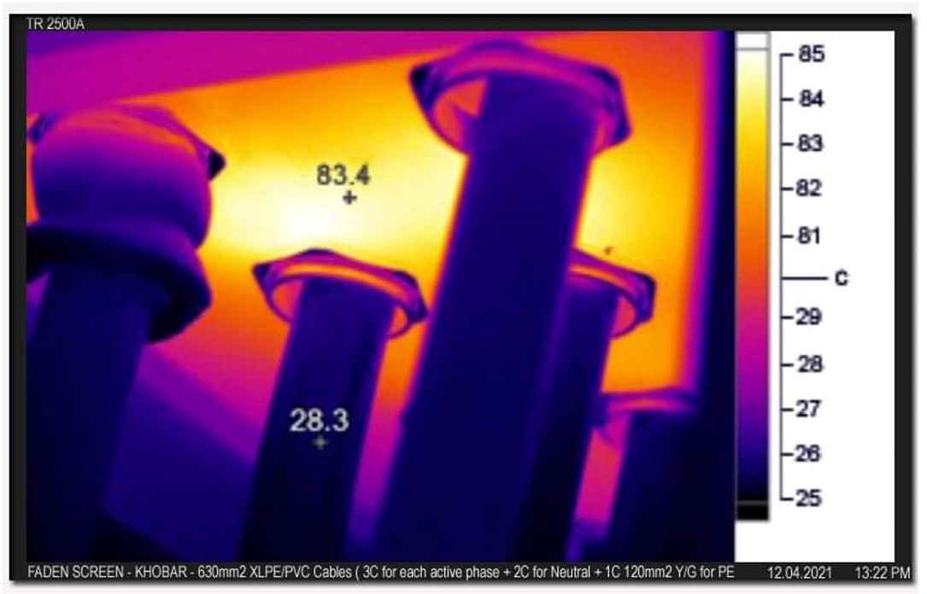
Thermal image, Figure (6)
The screen's forced cooling air conditioners (63 2-ton air conditioners + one 25-ton package air condition) were unable to balance even part of the capacitive load or reduce the temperature of the place where the cables exit from the ceiling of the main panel.
The apparent amperage on the neutral line exceeded 1100 amps at the white color, while the actual amperage on the active phases at the same color was less than 1000 amps.
3- Work environment:
The work environment was quite hostile, as it was impossible to install an active harmonic filter due to the crowded electrical rooms in the tower, and the size of the appropriate filter was so huge that it was impossible to find a place to place it, and it was also impossible to use IP65 enclosure and above to place the filter outside for technical reasons related to the need this type of filters for cooling.
4- Actual loads when starting work on screen brightness 100% when white color:
(Nature of pregnancy):
Non-linear load, where the entire system was analyzed from the moment of starting work using Power Analyzer ES4000
The waveform of the harmonics on the network was out of the ordinary, as is clear from Figure (7) [B].
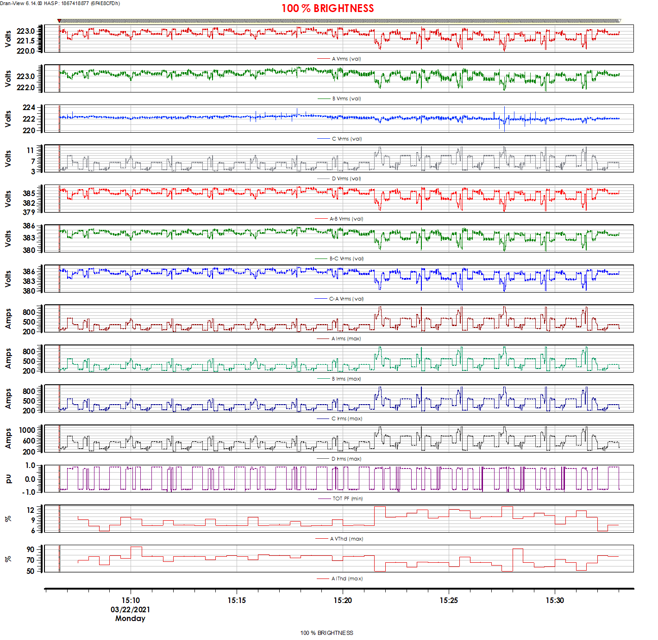
Figure (7).

The table below, based on the attached report called Power Analyze, shows the magnitude of the huge harmonics on the neutral line and the ground line:

$A$on PE | $A$on N | $\overline{A}$ on L | $\overline{L}$ to N | L to L
≠229A | ≠1134A | ≠995A | ≠220V | ≠380V
Result
Not Accepted | Not Accepted | OK | OK | OK

5- The grounding system at the moment of starting work:
The grounding system used to ground the MDB-3P+N/2000A supplying the screen was the grounding system located in the tower substation and extending over the entire tower mass.
It is a system built on a TN-S base and connected to the tower’s lightning system, and supported by the two compatible specifications:
IEEE Std. 998 -12/IEEE80-13.
The field readings on it were okay if the screen was not operating, and the resistance values of the ground with a large and close metal block were less than 2 ohms, which is a very good thing, but the problem begins when the screen is turned on, as the readings become as follows:
N to PE (100%) | N to PE (50%) | N to PE (OFF) | $\overline{L}$ to PE on Load 100% | $\overline{L}$ to PE on Load 50%
105MΩ | 20MΩ | ≈0.3-0.8 Ω | 170V | 92V
Not Accepted | Not Accepted | OK | Not Accepted | Not Accepted

6- Proposed solutions:
Understanding the nature of the problem was a crucial and fundamental factor in developing the action plan, and the only thing available to us that approximates the problem at hand is the SASO-IEC 61010-1-2019 standard that serves as a starting point.
We proposed to the owner to build an independent linear grounding to deal with the switched zero point. This applies to the screen feeding system as a whole, provided that the old grounding remains as a grounding against contact currents to protect individuals from electrification. After obtaining approval from the General Electricity Company, work was done as follows:
1- Support the neutral line coming from the transformer, which is: 2x1C 630mm2 XLPE/PVC, to become:
3x1C 630mm2 XLPE/PVC
2- Building a new ground and connecting it to the converted zero point based on the soil resistance study referred to previously.
3- Use low-resistance cement (Marconite) to improve the specific resistance of the sandy soil at the tower instead of coal and salt.
4- Adopting the TN-C system to connect the new linear ground to the neutral line in the main MDB panel, which allowed eliminating the apparent currents returning to the transformer and discharging them to the ground before returning to the Alexandrian transformer.
5- Keeping the old grounding to protect the panel body against touch currents.
6- Exploiting the tower’s huge metal mass to dissipate stray currents through the new grounding connect to the tower’s body
7- Use reverse loops when connecting the new ground to the tower body, because the tower body is already connected to the lightning control system, and this may pose a danger to the screen and its feeder panel for fear of side flashes when a lightning bolt maybe it strikes the tower at any time.
8- Do not use the ground connection system from more than one point towards the discharge vector, because it has proven to be a catastrophic failure and that it greatly raises resistance from non-main distribution points, despite all international standard specifications that have overlooked this.
Please review the new ground quality test file, named: (SAT for Adeer PE) [E]
These recommendations were later fully implemented.
The results were so acceptable that Faden Spectrum requested that the solution be circulated to four other screens suffering from the same problems.
It also canceled the issue of installing the APF active filter proposed by us, due to its own considerations on the one hand, and because the results were more than satisfactory to it.
(See Faden Spectrum’s attached message - which we are authorized to publish - about the reasons for canceling the installation of the active filter) [F]
The Results:
- The noise caused by harmonics was reduced from 95dB to 55dB at 50% illumination (which is the normal working rate for this type of screen at noon according to the manufacturer’s recommendations, which recommends [50-65%] illumination at noon) and the screen returned to working acceptably.
Note the image of the screen after it returns to work in Figure (8):
Figure (8)
- The ambiguous thermal field was eliminated once and for all by resorting to Drude's quantum interpretation of Ohm's law [9].
The roof of the plate (iron metal) was replaced with a roof made of Teflon with a thickness of 3 cm, which is a magnetic insulating material (note the thermal image after implementing this solution).
This quantum state will be addressed through independent research that is currently being prepared in cooperation with the Department of Physics at Tishreen University in Syria.
However, quickly: Note the thermal image in Figure (9) which shows the field overcoming after implementing the solution:
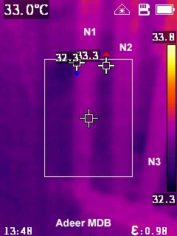
Figure (9)
- The apparent amperage on Neutral was reduced to 438A instead of 811A at the same brightness rate, which is an excellent percentage despite being non-standard. However, this solution reduces the size and capacity of the required active filter by half if the owners wanted to install it, and this is a huge saving of money.

- The annual rate of damage to the electrical and electronic components of the screen cells was reduced to less than 18%, after it had exceeded 70% at the same illumination rate, as is clear from Faden Spectrum’s letter to the work team[F].

- The electricity bill was reduced by ≈45% by reducing the waste resulting from VAr by directing it to the ground instead of returning it to the transformer, that appears clear in the image of the bill in Figure (10) [G], which shows a comparison of consumption after the solution with the same period of the previous year (note the decrease The sharp rate of consumption after applying the solution), which makes it a creative and relatively environmentally friendly solution, as it contributes in some way to reducing thermal emissions by legalizing the use of fossil fuels in generating stations due to reduc the electric power generation.

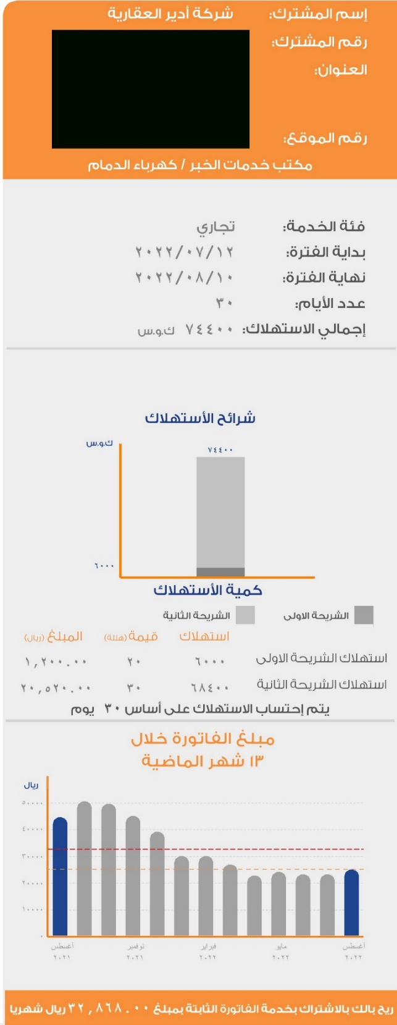
Figure (10)
Conclusions and recommendations:
Multi- or single-layer linear grounding [10] connected from one main point according to the TN-C system can significantly improve the performance of electrical networks against electromagnetic induction and capacitive harmonics, provided that the neutral cross section is enlarged at least twice and that the discharge vector is completely linear without any branches from Y-type or Δ-type closure
By linear grounding in its contemporary sense, we mean that extended interconnection grounding, multiple or single-layer, that can be connected to the lightning system [11], provided that it is connected to the main distribution panel at its beginning and is open at its end or connected to the lightning system at this end such that the vanishing point is the last stake.
Or the vanishing point must be the lightning system itself, with an emphasis on benefiting from the huge metal mass of the building in this case by connecting the last peg of the lightning system to the iron of the building itself to disperse the lateral flash of a lightning bolt that strikes the building or an electric shock that may strike the main distribution board (MDB).
Therefore it is in the shape of I or L, away from That is, the Y type, which has proven to fail due to the dramatic increase in resistance in shorter paths than the branch, or when it is closed according to the type Δ, despite all the standard specifications that overlooked this part because they were primarily concerned with grounding against touch currents.
Note the difference between extended linear grounding and other types of grounding according to the TN system in Figure (11)
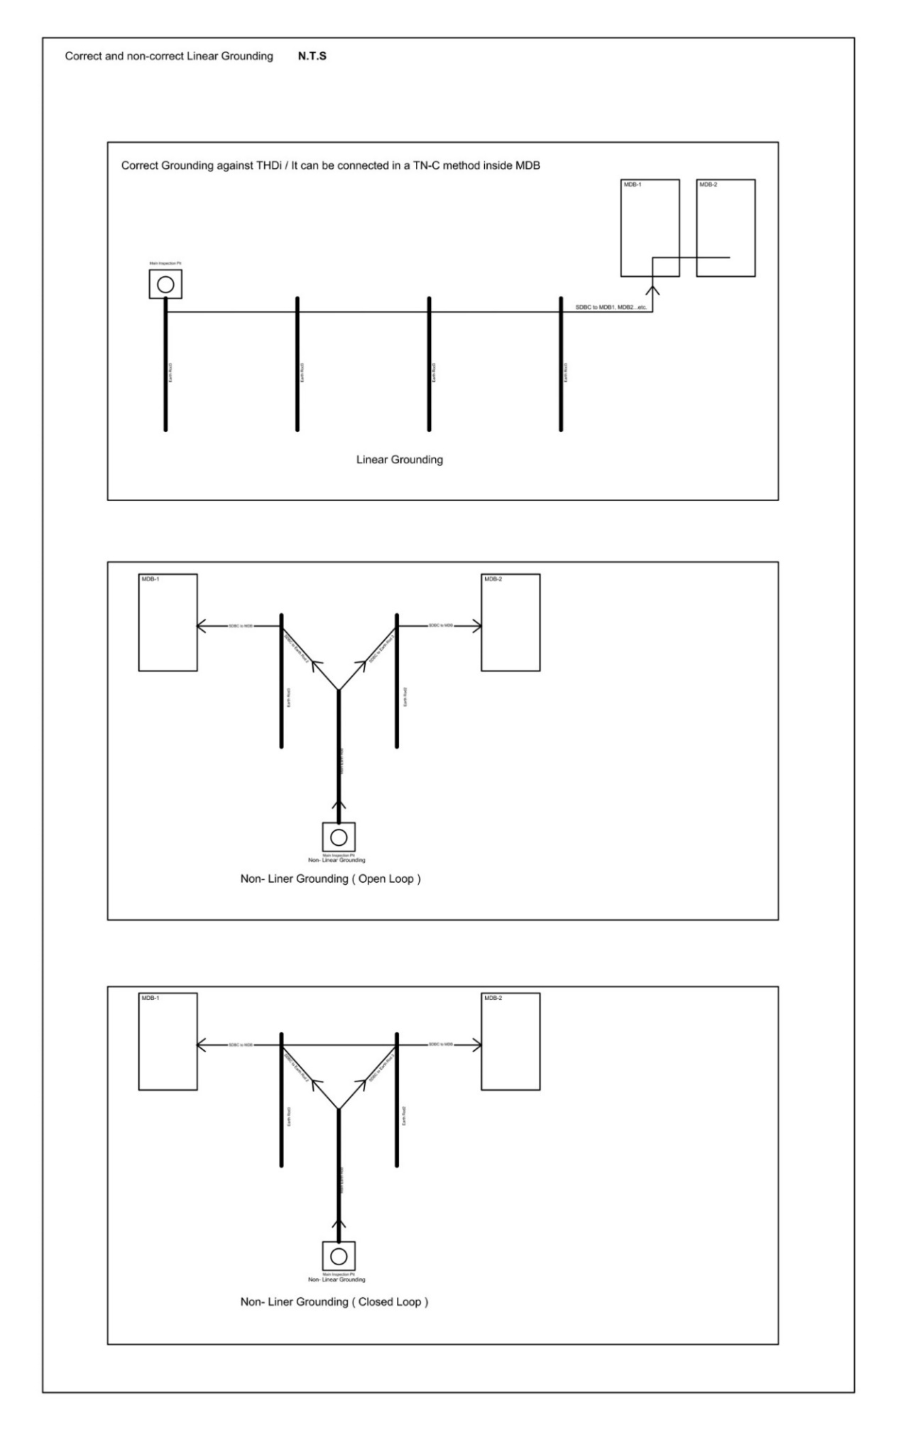
Figure (11)
“An image showing the difference between linear grounding and non-linear grounding according to the TN system / designed by the authors
Documents attached with this Research:
(Including thermal images, electrical measurements, data and condition reports provided by the authors' work team):
[A] Attached PDF, named: Soil Resistivity Testing
[B] Attached PDF, named: Faden Screen -Power Analyze
[C] Attached PDF, named: Adeer Thermal Photos
[D] Attached PDF, named: Status Reports
[E] Attached PDF, named: SAT for Adeer PE
[F] Attached PDF, named: Faden AHF Letter
[G] Attached PDF, named: Electrical Bill

References:
[1] Lundquist, Johan. Harmonic Distortion in Power Systems. Chalmers University of Technology: Department of Electrical Power Engineering, pp1,2. 2001
[2] IEEE Std 519-2014, IEEE Recommended Practices and Requirements for Harmonic Control in Electrical Power Systems, New York, NY: IEEE 2014
[3] Saham Electronic Newspaper. Faden Screen on Adeer Tower. awareness Campaign: https://sahmnews.com.sa/?p=14158 Riyadh SA 14.01.2021
[4] IEC Std 60502 cable, IEC Recommended Practices and Requirements Cables for Low Voltage in Electrical Power Systems, pp 6, 47. Geneva 2008
[5] IEEE Std 80-2013, IEEE Recommended Practices and Requirements for Safety in AC Substation Grounding, New York, NY: IEEE 2013
[6] IEC 60364-4-41, IEC Protection for safety –Protection against electric shock, pp 5, 11. With modifications and recommendations, Geneva 2005
[7] Referenced in IEC 60051-1; IEC 60065; IEC 60204-1; IEC 60204-32; IEC 60335-1; IEC 60335-2-17; IEC 60364-5-54; IEC 60445; IEC 60598-1; IEC 60688; IEC 60730-1; IEC 60878; IEC 60950-1; IEC 61008-1; IEC 61009-1; IEC 61010-2-201; IEC 61140; IEC 61310-2; IEC 61347-1; IEC 61534-1; IEC 61730-1; IEC 61800-5-1; IEC 62052-31; IEC 62057-1; IEC 62368-1; IEC 62477-1; IEC 62933-5; ISO/IEC 13251
[8] IEEE Std. Grounding System Types According to IEEE Standard, TN-TT-IT, New York, NY: IEEE 2007
[9] Konstantin K. Likharev, The Ohm law and the Drude formula, Stony Brook University- Department of Physics pp 6.2.1-6.2.17 Publication date not specified.
[10] IEEE Transactions on Magnetics. An improved linear grounding system analysis in two-layer earth (Volume: 32, Issue: 5, pp 5179 – 5187). September 1996. New York
[11] For briefing and more information about INTERCONNECTION OF GROUNDING FOR LIGHTNING PROTECTION AND GROUNDING FOR ELECTRICAL INSTALLATIONS, kindly visit:
https://zandz.com/en/library/interconnection-of-grounding-for-lightning-protection-and-grounding-for-electrical-installations/

